REXTON ELEMENTARY’s
SCHOOL IMPROVEMENT PLAN
2010-2011


REXTON ELEMENTARY’s
SCHOOL IMPROVEMENT PLAN
2010-2011

School Mission Statement
To encourage the development of each student’s full potential by nurturing a love of learning and fostering respect for the uniqueness of each individual through a safe and friendly school community.

Rexton Elementary’s
2010-2011 School Improvement Plan
School District 16


- School Demographics

The Rexton Elementary School is a modern educational facility located in the village of Rexton, New Brunswick. This K-5 school serves the large, mainly rural, geographic area of Kent County. The population is diverse with many students coming from bilingual homes and communities where English/French or English/Mi'kmaq is spoken. Also, approximately one-third of the children come from the First Nations Communities of Bouctouche, Indian Island, and Elsipogtog.
Rexton Elementary has 258 students,18.6 teachers, 8 Teacher Assistants, two First Nations Liaison personnel, one part-time Librarian Assistant, and 3 custodians. RES also has an active Home & School Association and PSSC which collaborate with Rexton Elementary’s teaching and non-teaching staff to ensure that our school is a safe and positive learning environment.

- Instruction and Curriculum

Rexton Elementary School strives to be a positive learning environment for all students and staff. Provincial curriculum materials, instructional strategies and supports, professional development and student assessments are utilized to ensure higher student achievement.

III. STANDARDS

90% of RES’ K-5 students will attain acceptable or above on their grade level school, district, and provincial assessments.

IV. MEASURES

Rexton Elementary School’s achievement in literacy and numeracy from 2010-2011 will be measured through school/District 16-based summative assessments for students at the grade K-5 grade levels. RES will also utilize grade 2 and grade 4 provincial standardized assessments to measure achievement in literacy; Rexton Elementary will measure our grade 3 and grade 5 numeracy achievements utilizing the provincial numeracy assessments.

Data Collection
Literacy:
- The K-5 School-Based Text Level Reading Results, fall 2010.
- The K-5 School-Based Writing Assessment, fall 2010.
- The District’s Fast ForWord Data, winter 2010.
- The District’s K-4 AIMSweb Data, fall 2010.
- The Grade 2 Provincial Assessment Results in Literacy, spring 2010.
- The Grade 4 Provincial Assessment Results in Literacy, spring 2010.

Numeracy:
- The K-1 School-Based Assessment Results in Mathematics, fall 2010.
- The District’s End-of-Grade-2 Assessment Results in Mathematics, fall 2010.
- The District’s Grade 4 Assessment Results in Mathematics, spring 2010.
- Grade 3 Provincial Assessment Results in Mathematics, spring 2010.
- Grade 5 Provincial Assessment Results in Mathematics, spring 2010.

Data Collection (continued)
Behavioral:
  - WinSchool Behavior Tracking Data
  - Respect and Responsibility Room Data
  - WinSchool Attendance Data

Teacher Growth & Leadership
- 2009-2010 Provincial Perception Survey (students, parents, and teachers)
- School-based Bullying Perception Surveys (students, parents, and teachers)
- School-Wide Curriculum Mapping, Common Formative Assessments
- Professional Growth Portfolio Goals & Indicators of Success
- Response to Intervention & PLC Team Meetings data
- Participation in Book Studies & Extra Curricular Activities data
- Participation of teachers, TAs and Administrators in Conferences/Workshops and School-Based Professional Development Presentations

Measures/Data
 | Provincial |  | District 16 |  |  |  |  | Rexton Elementary School
 | Literacy Assessment | Math Assessment | Observational Survey | Text Placement | AIMSweb | Math Assessment | Fast  ForWord | Math  (Prime or End of Grade Level) | Sight Words | Writing Samples  (Monthly) | Attendance | Behavior Tracking
K |  |  | √ | √ | √ |  |  | √ | √ | √ | √ | √
1 |  |  | √ | √ | √ |  |  | √ | √ | √ | √ | √
2 | √ |  |  | √ | √ | √ | √ |  | √ | √ | √ | √
3 |  | √ |  |  | √ |  |  |  | √ | √ | √ | √
4 | √ |  |  |  | √ | √ |  |  |  | √ | √ | √
5 |  | √ |  | √ |  |  |  |  |  | √ | √ | √
IV. RES Student Performance on Provincial Assessments

Provincial 2010 Grade 2 Literacy Assessments:

The results of the 2010 Grade 2 Provincial Literacy Assessment indicate that 77.5% of Rexton Elementary students scored at the appropriate level or higher in reading comprehension compared to 87.5% in 2009 and 81.2% in 2008. The 2010 Provincial Reading Comprehension Assessment results indicate that Rexton Elementary’s grade 2 students surpassed Rexton Elementary School’s 2009-2010 reading comprehension objectives by 4.5%. We were pleased that 26.5% of Rexton Elementary’s grade 2 students reached the level of Strong Achievement in reading comprehension; we had predicted that 27% of our grade 2 students would be able to reach the level of Strong Achievement in reading comprehension.
The results of the 2010 Grade 2 Provincial Literacy Assessment also indicate that 65.3% of RES’ students reached the appropriate level or higher in writing compared to 62.5% in 2009 and to 64.6% in 2008. RES’ 2009-2010 writing achievement results indicate that we surpassed our school’s 2009-2010 objective of having 65% of our students score at or above the acceptable level in the Provincial Literacy Assessment in writing!
.
We were disappointed to see, however, that in the spring of 2010 only 2.0% of Rexton Elementary’s grade 2 students reached the level of Strong Achievement in writing

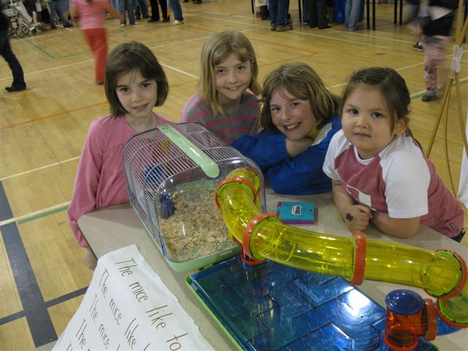

Provincial 2010 Grade 4 Literacy Assessments:

.The results of the 2010 Grade 4 Provincial Literacy Assessment indicate that 87.2% of RES’ grade 4 students achieved at the appropriate level or higher in reading comprehension, compared to 94.3% in 2009 and 72.1% in 2008. We were absolutely delighted, however, that this year’s grade 4 students surpassed RES’ 2009-2010 Reading Comprehension objective of having 80% of our grade 4 students achieve at the appropriate level of higher in reading comprehension.
19.1% of RES’ Grade 4 students reached the level of Strong Performance in the 2009-2010 Grade 4 Provincial Reading Comprehension Assessment compared to 38.5% in the 2009 Provincial Reading Comprehension Assessment, however, RES’ Grade 4 students did surpass RES’ 2009-2010 Reading Comprehension objective of having 15% of our students reach the level of Strong Performance in the Reading Comprehension Assessment.
The 2010 Grade 4 Provincial Literacy assessments indicate that 55.4% of our students reached the appropriate level or higher in their writing assessments, compared to 55.8% in 2009 and only 37.7% in 2008. Unfortunately, RES’ Grade 4 students were unable to meet RES’ 2009-2010 writing objective of having 66% of our students achieving at or above level in writing.
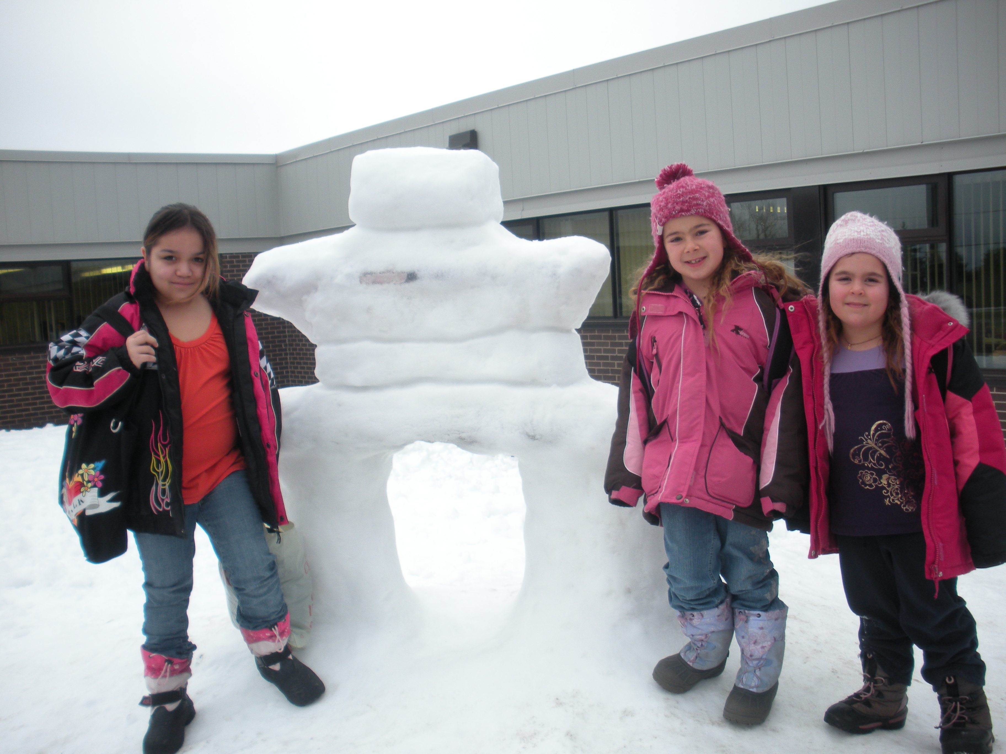
Data Analysis of RES’ Provincial Assessment Results:
LITERACY:
Rexton Elementary’s teaching team concluded, after extensive analysis of RES’ 2009-2010 Grade 2 & 4 Provincial Literacy data, that there were several key factors that contributed to RES meeting OR surpassing our established literacy objectives:
- District 16 allotted RES 1.0 for Methods & Resource during the 2009-2010 school year compared to .8 in the 2007-2008 school year.

- District 16 allotted RES .5 FTE to implement the best in Response to Intervention - Reading Recovery

- Ongoing and extensive Daily 5 support/mentoring for our Grade 2 teachers was provided by District 16 Clinicians

- RES’ 2009-2010 teaching schedule provided Response to Intervention for all grade levels and Professional Learning Community time for teachers to meet, share and plan lessons and/or create common formative assessments with their teaching colleagues.

- During the 2009-2010 school year, extensive literacy interventions were provided to our grade 2 students (Empowering, a four week writing intervention implemented by a retired literacy teachers/administrator),

- Students were taught how to become independent reader, using the Daily 5 program; students were also allotted extensive and consistent time within the instructional day to read to self, read to someone. RES’ 2009-2010 Homework Action Study ensured that our families were focusing on the importance of reading together daily.

- Greater emphasis was placed on teaching RES’ Grade 2 students how and why to use WOW words.

- RES’ Grade 2 students were taught how to ensure that their writing had proper sentence structure, using red/green pens when editing (Lucy Calkins’ writing strategy).

Our teaching team concluded, after extensive analysis of Rexton Elementary’s 2009-2010 Grade 2 & 4 Provincial Literacy data, that there were several key factors that may have contributed to our not meeting our established literacy objectives:
- 29% of our Grade 2 students and 19% of our Grade 4 students were on either an Accommodated or Modified Special Education Program during the 2009-2010 school year, compared to 14% and 7% respectively in 2008-2009.

- Increased attendance issues with many of our students due in part to the H1N1 pandemic.

- Behavorial issues with several of RES’ Grade 2 and Grade 4 students; in fact, one student was unable to attend school and subsequently write the provincial literacy Assessment because the child was involved in a District 16 Threat Assessment/Investigation during the provincial assessment period. A grade 4 child, with behavioral issues, also refused to write the provincial assessment.

- All Grade 2 students were required to participate in an hour a day Fast Forward™ Program, whether they needed it or not; this contributed to RES’ stronger students not realizing their full potential due to the fact that they were involved in a program that was not a “good fit” for their needs.

- Our teachers were very surprised by our 2009-2010 Grade 2 provincial literacy assessment results due to the fact that they had carefully followed the provincial 6+1 Traits Rubric when they reviewed their student’s writing assessments; RES’ teachers had predicted that greater than 65% of our grade 2 students should have achieved a Strong Performance rating.

RES’ 2009-2010 Provincial Literacy Assessment Results indicate that Rexton Elementary needs to ensure that:
- All K-5 teachers continue to improve our implementation of best practices which are outlined in the provincial K-2 AND 3-5 Literacy Look-Fors.
- All RES teachers teach our students to become independent in the acquisition of essential literacy and metacognition skills (i.e. The Daily 5 program).
- All K-5 teachers work towards developing greater skills in the area of teaching students how to become authentic writers.

NUMERACY:
Rexton Elementary’s 2009-2010 Grade 4 District Mathematics results indicate that 60% of our students achieved at or above the appropriate level compared to 75% in the 2008-2009 Grade 4 District Mathematics Assessment results.
The Grade 5 Provincial Mathematics results (spring, 2010) indicate that 65.4% of our students scored at the appropriate level or higher, compared to 54.8% in 2009! RES scored at the Appropriate Achievement (AA2) level in the overall Grade 5 Provincial Mathematics which is an improvement from our AA1 level score for the 2008-2009 Mathematics Results! 13.5% of our grade 5 students scored at the Strong Performance level in the provincial 2009-2010 Grade 5 Mathematics Assessment compared to 14.5% in the 2008-2009 school year.
Data Analysis of RES’ Provincial Mathematics Assessment Results:
Rexton Elementary’s teaching staff attributed our improved performance on the 2010 Provincial Mathematics Assessment to:
- RES’ Grade 5 students were overall stronger Mathematical students compared to the 2008-2009 Grade 5 students.
- RES’ Grade 5 teachers had acquired expertise and greater confidence in teaching the Grade 5 Mathematics curriculum.

- RES’ Grade 5 teachers made a conscientious decision to schedule their instructional Mathematics periods from late afternoon (2008-2009) to the first two periods in the morning, which resulted in the students being more alert when learning and practicing mathematical skills/concepts.

Rexton Elementary’s teaching staff attributed our decreased performance on the 2009 Provincial Mathematics Assessment was a result of having:

- 13% of RES’ 2009-2010 Grade 5 students were on an accommodated or modified SEP, compared to 7% in the 2008-2009 school year.

- RES’ teaching staff did not have sufficient time to teach certain Mathematics strands and because priority had been given to programs at previous grade levels (Fast ForWord, Literacy Interventions, etc).

Rexton Elementary’s teaching staff attributed our decreased performance on the 2009 District 16 Grade 4 Mathematics Assessment to:

- 19% of our Grade 4 students were on an accommodated or modified SEP.
RES’ 2009-2010 Provincial & District Mathematics Assessment Results indicate that Rexton Elementary School needs to:

- Place greater emphasis on teaching in the Number and Shape/Space mathematical strands at all grade levels.

- Begin tracking, analyzing and providing numeracy interventions for our K-1 students.

- Provide more Response to Intervention time to our Grade 5 students throughout the school year in addition to the M5 late-winter intervention.

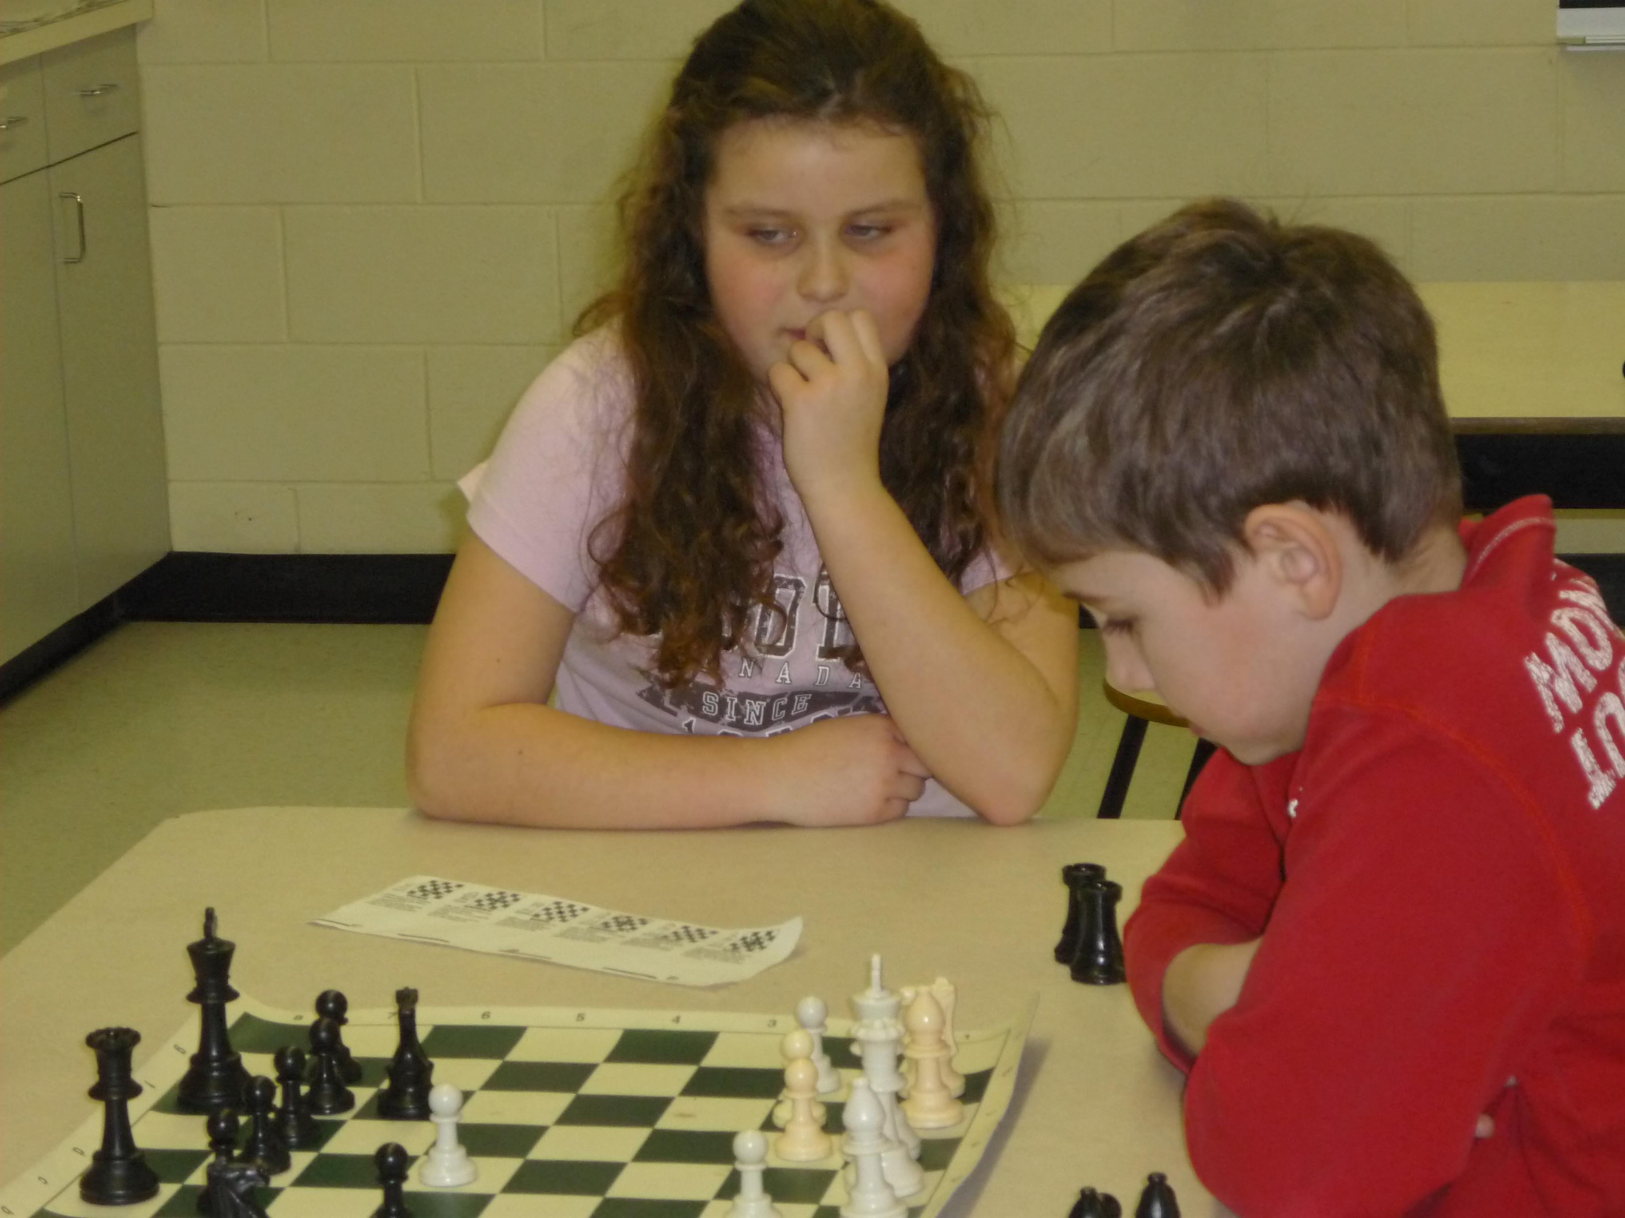

RES’ 2010-2011 Achievement Predictions
2010-2011  Provincial Assessments | % of RES Students Who We Anticipate Will Achieve BAA | % of RES Students Who We Anticipate Will Achieve AA | % of RES Students Who We Anticipate Will Achieve Strong Achievement Level
K-1 Observational Survey | 33% | 35% | 32%
K-3 Sight Word Assessment | 20% | 80% | NA
Grade 2 Fast ForWord Assessment | 30% | 57% | 13%
K-4 Text Placement | 25% | 50% | 25%
K-4 Writing Assessment (monthly) | 27% | 56% | 17%
Grade 2 Provincial Reading Assessment | 36% | 38% | 26%
Grade 2 Provincial Writing Assessment | 32% | 59% | 9%
Grade K-2 District Mathematics Assessment | 13% | 83% | 4%
Grade 4 Reading Assessment | 27% | 41% | 32%
Grade 4 Writing Assessment | 39% | 46% | 15%
Grade 4 District Math Assessment | 15% | 61% | 24%
Grade 5 Math Assessment | 25% | 65% | 10%

G0AL: To increase the Literacy and Numeracy skills of all Rexton Elementary School students AND cultivate 21st Century Skills and Teacher/Leadership Growth

OBJECTIVES FOR 2010-2011:
          - To increase our students results on the Provincial Literacy Assessments by 2% in reading and 10% in writing.
          - To increase our students results on the Provincial Numeracy Assessments by 3% in Mathematics.
          - To implement 21st century skills and strategies within our positive learning environment.

STRATEGIES:
Rexton Elementary School teaching staff will continue to focus its strategies in the following areas:
- Increase Literacy Growth
- Improve Numeracy Growth
- Cultivate 21st Century Skills: Teacher & Leadership Growth
The Rexton Elementary staff will focus on plans to support the above strategies, as part of our District’s initiatives for the continuous improvement of schools. Our teaching staff has been assigned specific duties related to one or more of these strategies. Each of our grade levels have specific goals and associated programs with these goals to support success.
The implementation plans charted below are for the 2010-2011 school year.

Rexton Elementary’s 2010-2011 Implementation Plan

- Increase Literacy Growth
Provincial Goal: When Kids Come First – 90% of kids reach the reading standard at Grade 2 and again at Grade 4, 20% exceed it.

District 16 Objective: Increase the results in Provincial Literacy Assessments in Grade 2 Reading by 2% (increase the results in
Provincial Literacy Assessments in Grade 2 Writing by 10%):

RES’ 2010-2011 Objective: Increase our results in the Provincial Grade 2 and 4 Literacy Assessments by 2%.
- Grade 2 Reading: 79.5%
- Grade 2 Writing: 75.3%
- Grade 4 Reading: 89.2%
- Grade 4 Writing: 57.4%
Objective | Strategy | Person(s) Responsible |  | Indicators of Success | Timeline | Monitored By
To increase our students’ results on the provincial Literacy Assessments by 2% in reading and 10% in writing | Observational Survey Training for new Primary Teachers | Teachers new to the primary wing |  | All new primary teachers will have received training in Observational Survey | September 2010 | Diane Wilson
 | Provision of AIMSweb training for new teachers at applicable grade levels | Annette Hendry  Cynthia Wood  Wendy McLaughlin  Diane Wilson |  | All K-4 teachers will have received AIMSWEB Testing training and this data will be used to inform instruction. | September 2010 | Diane Wilson
 | Continuation of the Kindergarten & Grade 1 Zoo Phonics Program | Kindergarten and Grade 1 teachers |  | K-1 teachers will utilize the program within their daily balance literacy program. | September 2010-June 2011 | Diane Wilson  Virginia Richard
 | School-based Training will be provided in ABC Boom for new Primary Teachers; | K-2 Teachers |  | All RES teachers will have provided assistance/guidance to new primary teachers.  RES’ K-2 teachers will attend ABC Boom training provided at the District level. | Ongoing | Diane Wilson  Virginia Richard
 | Implementation of the Daily 5 Literacy program within our K-5 Literacy Classrooms | K-5 Teachers Annette Hendry  Nancy Scully |  | Teaching staff will have attended Annette Hendry’s after-school Café workshop. | June 2010 | Diane Wilson  Virginia Richard
 |  |  |  | K-5 teachers will have participated in a Jigsaw Activity using the Daily 5 resource. | June 28/10 | Diane Wilson  Virginia Richard
 |  |  |  | Clinicians will have modeled the Daily 5 program at K-3 grade levels | September 2010 –June 2011 | Diane Wilson  Virginia Richard
 |  |  |  | Daily 5 video presentations will have been presented at staff meetings | September 2010 – December 2010 | Diane Wilson  Virginia Richard
 |  |  |  | RES’ grades 1, 2, 3, 4 teachers, with the exception the French Immersion teacher, will have implemented at least three components of the Daily 5 program within their classrooms. | September – December 2010 | Diane Wilson  Virginia Richard
 |  |  |  | RES’ grade 5 teachers will have implemented at least three components of the Daily 5 literacy program within their compacted language arts program. | February-May 2011 | Diane Wilson  Virginia Richard
 |  |  |  | Study Group/Pilot Teachers will implement The Café to augment the Daily 5 Program | January – May 2011 | Diane Wilson  Virginia Richard
 |  |  |  | RES will have purchased Daily 5 website licenses. | November 2010 | Diane Wilson  Virginia Richard
 | Kinder Club | Nancy Scully & Kindergarten teachers |  | There will have been growth in phonemic & phonological awareness & text placement for Kindergarten students | January – February 2011 | Diane Wilson  Virginia Richard
 | Literacy Links | Nancy Scully & Grade One Teachers |  | There will have been text placement gains and writing development growth | January – February 2011 | Diane Wilson  Virginia Richard
 | Reading Recovery | Virginia Richard |  | Students will have reached level 16 and be independent readers. | September 2010 –  June 2011 | Diane Wilson
 | Grade 3 FI Intervention | Julia Mazerolle Monica Lockerlie |  | FI teacher and students will have received support in acquiring French second language training by District 16 FI mentor. | September 2010 | Diane Wilson
 | Peer Readers | Grades K- 5 |  | Students in grades 3-5 will have listened to their K-2 Buddies read, conducted flashcards drills, and modeled fluent reading. | September 2010 –  June 2011 | Virginia Richard
 | Fast ForWord | Grade 2 teachers  Virginia Richard |  | 85% of grade 2 students will have reached Reading Level 2 | November 2010 –  January 2011 | Dian Wilson
 | Grade 2 Empowering Intervention | Nancy Scully  (Literacy Clinician) |  | There will have been text placement gains and writing development growth | October 2010 | Diane Wilson  Virginia Richard
 | Common Reading Assessments | K-5 classroom teachers |  | Regular and frequent Reading Record Assessments will have been conducted to determine instructional practice and to monitor reading development | October 2010  March 2011  June 2011 | Diane Wilson  Virginia Richard
 | Creating and organizing 3-5 Literacy Room | K-5 Teachers & Nancy Scully |  | RES will have order new non-fiction picture books for our K-3 students and organized these materials to meet the needs of our classroom teachers. | September 2010 | Diane Wilson  Virginia Richard
 | K-2  Battle-of-the- Science-Books  Event | K-2 teachers |  | Students will have acquired scientific knowledge and increased their reading stamina whilst participating in a Battle-of-the-Books Event. | May 2011 | Diane Wilson  Virginia Richard
 | Mad Science | K-5 teachers |  | This hands-on science exploration program will have been made available to RES’ K-5 students at a noon time assembly and after school bi-monthly. | January 2011 | Diane Wilson
 | 3-5 Battle-of-the-Books Event | 3-5 teachers  Wendy McLaughlin |  | Students will have increased their reading stamina whilst participating in a Battle-of-the-Books Event. | May 2011 | Diane Wilson  Virginia Richard
 | French Oral Language presentations | Grade 3, 4, AND 5 French Second language teachers |  | French Second Language teachers will have prepared their students so that they would be able to perform for authentic audiences: classes, Assemblies, website, etc. | Monthly from  September – June 2011 | Diane Wilson
 | Literacy Night | RES’ Administrators  Literacy Clinicians  K-5 teachers |  | Literacy Night/Author’s Alley will have been successfully orchestrated with students, parents and teachers coming together to learn about and play literacy activities. | January and June 2010-2011 | Diane Wilson  Virginia Richard
To increase our students’ writing achievement | 6+1 Marking Sessions | K-5 Literacy Teachers  Kim Beers  Angela Savory  Nancy Scully |  | 1 .RES’ K-2 & Grades 3-5 teachers will have conducted bi-weekly marking sessions utilizing grade level writing samples.  2. Excel system will have been implemented to track each student’s writing development. (Staff should collect, analyze, and use data in all four key areas of student achievement).  3. K-5 classroom teachers & RES Administrators will have made a school visit to observe how they conduct their writing workshop.  4. RES will have invite Depart of Education’s Sandra Mazerolle to come to our school to present a workshop on marking grade 2 & grade 4 writing samples.  5. RES will have devise writing exemplars for the beginning/middle of each grade level.  6. Grade 2 teachers & Literacy Clinician will have provided in-servicing to K-5 teachers regarding the successful use of colored pens to assist students with the editing process.  7. Purchase Month-by-Month Phonics resource for grade 3 teachers | Ongoing  November 2010  November 2010  November 2010  December 2010 -January 2011  November 2010  October 2010 | Diane Wilson  Virginia Richard
 | Text Forms for Certain Grade Levels | RES teachers |  | K-5 teachers will have come to a consensus regarding what text forms will be highlighted at various grade levels. | November 2010-June 2011 | Diane Wilson  Virginia Richard
 | Provide school-wide initiatives to motivate students to write | RES’ Administrators,  K-5 teachers and Literacy Clinicians  Diane Wilson  Kevin Rioux  Barry Robertson  Frank MacPhee  Bernie Landry |  | 1. We will have incorporate student writing into monthly newsletters, website, and Assemblies.  2. RES’ Student Council will be responsible for assisting with the creation & manage the school website morning announcements and they will also submit monthly articles to school newsletter and create posters for our Playground Committee fundraising events.  3. Teachers will have displayed student writing on Principal’s Writing Wall of Fame bulletin board/webpage; classroom teachers will provide opportunities for their students to read the writing samples on the Principal’s Writing Wall.  4. RES will have initiated a RES Small Frye festival OR Poetry Month.  5. RES will have initiated a Boys Writers Club whereby male students will come together and explore various writing genres | Ongoing  September 2010 – June 2011  Ongoing  Ongoing  March – April 2011  January – June 2011 | Diane Wilson
 | Scheduled RTI time | Administrators, Methods/Resource Teacher,  Literacy Clinicians |  | Response to Intervention Time to provide timely literacy intervention will have been made available in RES’ weekly Teaching Timetable | September 2010-June 2011 | Diane Wilson
Monitoring
NOVEMBER |  |  | MARCH |  | MAY
Revised Action(s) – if off target |  |  | Revised Action(s) – if off target |  | Revised Action(s) – if off target
- Improve Numeracy Growth

Provincial Goal: When Kids Come First – 90% of students reach numeracy standard at Grade 3 and 5, 20% exceed it. 85% of students will reach numeracy standards in Grades 6-12.

District 16 Objective: Increase the results in Provincial Numeracy Assessments in Grade 5 Math by 3%.

Rexton Elementary Objective: Increase the results in our Grade 5 Provincial Numeracy Assessments by 3% (to 68.4%)

Strategy | Action Plan | Person(s) Responsible | Indicators of Success | Timelines | Monitored By
To increase our students’ results on the Provincial Numeracy Assessment by 3% in Mathematics | Common planning and common mathematics assessments at grade levels | K-5 teachers | Grade level teachers will have focused on essential outcomes to create common assessments and will have met to evaluate and reach consensus about grade level assessments. | Ongoing | Diane Wilson &  Virginia Richard
 | Response to Intervention for Numeracy | K-5 Teachers | Individual student numeracy needs will have been met within the regular instructional day. | September 2010 - June 2011 | Diane Wilson  Virginia Richard
 | Research methods of teaching students their operation facts | K-5 teachers  Kim Bowes  Janice Hall-Short | Students will have completed the year with increased confidence and capabilities in the operations strand. | 2010-2011 | Diane Wilson  Virginia Richard
 | Mad-Math Minutes | 1-5 numeracy teachers | Teachers will have conducted regular & frequent formative assessments to direct their instruction in relation to their students’ acquisition of skills in the operations strand | 2010-2011 | Diane Wilson  Virginia Richard
 | Integrating mathematics and technology  (math facts sites) | Stephanie Flanagan  Toby Daigle  K-5 Teachers | - Teachers will have utilized Smart Boards, Websites, and online resources to engage students in mastering their grade level numeracy outcomes.  - RES will have purchased classroom licenses for Brain Pop | November 2010 –June 2011 | Diane Wilson  Virginia Richard
 | Integrating mathematics and technology  (math facts sites) | RES’ teachers  Katherine Halas Moulton | - Smartboard Workshop will have been provided all teachers of mathematics to illustrate the newest Smartboard tools available | November 5th, 2010 | Diane Wilson
 | M5 Intervention & RTI will be provided students needing additional support in developing numeracy skills | K-5 numeracy teachers  Kim Bowes  Janice Hall-Short | Students who have been identified as needing numeracy support will have daily intervention/support. Students needing intensive mathematics support will participate in the M5 Intervention in February and March.  -Daily Math Intervention for each Grade 5 class will have been provided daily | February - March 2011  October 2010 –  June 2011 | Diane Wilson  Virginia Richard
 | Revising RES’ Homework Policy | RES’ Homework Committee and classroom teachers | Homework will have been determined by grade level teachers based on the needs of their students;  - Homework schedule will have been given to students and their families. | September 2010 – June 2011 | Diane Wilson  Virginia Richard
 | RES ‘ K-5 Chess Club | Diane Wilson  Kevin Rioux | Chess Club (utilizing peer mentors) will be available to all interested students, during noon recesses, | November 2010 – April 2011 | Diane Wilson
Monitoring:
NOVEMBER |  | MARCH |  | MAY
Revised Action(s) – if off target |  | Revised Action(s) – if off target |  | Revised Action(s) – if off target

- 21st Century Skills: Teacher & Leadership Growth
Objective | Strategy | Person(s) Responsible |  | Indicators of Success |  | Timelines | Monitored By
To implement 21st century skills and strategies within our positive learning environment | Grade Level & vertical PLC Time will be scheduled to provide vital meeting time to explore 21st century skills | RES’ Administrators  K-5 Teaching Teams |  | K-5 teachers will devise a schedule for their bi-monthly PLC meetings (after 2:30 p.m.) thus ensuring that their administrators and Resource teacher are able to attend these meetings as well.  Our teaching teams will have met and planned common goals and assessments twice monthly. We will have determined whether our students have mastered the concepts that were taught and who needs extra support utilizing teacher/student created rubrics.  There will be monthly vertical grade level meetings (K-2 & 3-5) to participate in marking writing samples, review PD 360 videos, and update/modify our Pyramid of Interventions.  Grade Level Team Meetings:  All K-3 homeroom teachers will have been provided time to meet daily, during the instructional day, to discuss common assessments, curriculum mapping, and common instructional issues.  Grades 4-5 teachers will have two periods per five day cycle to meet and plan curriculum together within the instructional day |  | September 2010 –  June 2011 | Diane Wilson  Virginia Richard
 | Professional Learning Community Book Studies:  - 21st Century Skills  - CAFÉ  - Enhancing Professional Practice | RES Administrators and RES teaching team |  | RES’ teachers will have had the opportunity to participate in the 21st Century Skills, Café and Enhancing Professional Practice book studies.  Book study participants will have presented, at a staff meeting, an overview of concepts in book studies |  | September 2010 – June 2011 | Diane Wilson  Virginia Richard
 | Enhancing Professional Practice Framework | RES Teachers |  | Principal will have presented to teachers an overview of the Enhancing Professional Practice framework  RES’ Administrators will have implemented the Framework teacher feedback program with teaching staff & will have provided feedback to teachers  All RES’ classroom teachers will have met to determine their success/needs in relation to the provincial Look-Fors documents. Emphasis will have been placed on the link between the Daily 5 and The Café Book to curriculum documents and literacy Look-Fors..  All RES classroom teachers will have visited a classroom in our school, district, or province that is currently exhibiting 21st century teaching/learning. |  | October CI Day, 2010 - June 2011 | Diane Wilson  Virginia Richard
 | Reflecting Various Cultures | - Mona Francis  - Charity Barlow  - Vietnam, Korean, Chinese & French RES parents |  | RES will have developed projects where students can create permanent installations that reflect aspects of the various cultures represented in our school and create a mindset of accepting multiple languages and cultures. |  | February 2011 | Diane Wilson
 | Reflecting Various Cultures | Diane Wilson |  | Principal will have attending national French Conference to learn how to celebrate our bilingual culture in our elementary school. |  | October 2010 | Diane Wilson
 | Differentiated Instruction | RES’ K-5 Teachers |  | K-5 teachers will have created their lesson plans to reflect the diverse students we serve; teachers will have received feedback on their lessons from RES administrators. |  | September 2010 –  June 2011 | Diane Wilson  Virginia Richard
 |  |  |  | Investigate and seek clarification as to what K-5 lesson plan should consist of in the 21st century. |  | Ongoing | Diane Wilson  Virginia Richard
 | Learning Style Committee | Angela Savory  Maggie Murphy  Stephanie Flanagan |  | Committee will have researched and selected learning style inventories that will meet the needs of RES’ classroom teachers & students |  | November 2010-January 2011 | Diane Wilson  Virginia Richard
 |  |  |  | RES’ Learning Style Committee will present its findings at a regular staff meeting |  | May 2011 | Diane Wilson  Virginia Richard
 | Alignment of Professional Growth Goals with RES’ 2010-2011 SIP | All RES Teachers, Teacher Assistants, AND Clerical Staff |  | RES’ Portfolio Goal facilitators will have ensured that all RES Professional Growth Goals aligned with RES’ 2010-2011 SIP. |  | September 2010-June 2011 | Diane Wilson  Virginia Richard
 | Weekly Administrator Meetings | RES’ Administrators  Guidance Councilor  Resource Teacher  Intervention Workers  Literacy Clinicians |  | Meeting with administration to review the data (AIMSweb, formative/summative school/district-based & provincial) will have assisted with determining what interventions were needed as well as areas where interventions were successful. |  | September 2010 – June 2011 | Diane Wilson  Virginia Richard
 | Modify Resource Teacher’s schedule to ensure greater access to K-5 students/classes | Barry Robertson  RES’ Administrators |  | All K-5 grade levels will have had equal access to our Methods and Resource teacher thus ensuring that a greater number of students will have benefited from working with the Methods and Resource teacher and enable him to have more impact on planning for students with individualized SEPs. This schedule change will have provided more effective monitoring of SEPs and working directly with grade level teams will also have resulted in more effective collaboration/consultation. |  | September 2010-June 2011 | Diane Wilson
 | Students with exceptionalities, who work with Teacher Assistants, will have more direct supervision by a teacher | Barry Robertson  Colleen Wilt  Zoella Vienneau  RES K-5 classroom teachers |  | Administrators will have requested that District Student Services supervisors meet with RES’ Administrators & Resource teacher when adjustments are made to a SEP program. |  | Ongoing | Diane Wilson  Virginia Richard
 | District 16’s  21st Century Symposium | Diane Wilson  Barry Robertson  Sheena Sturgeon |  | Members of RES’ PSSC will attend District 16’s 21st Century Symposium and present their findings at our January 2011 PSSC meeting. |  | November 9th & January 2011 | Diane Wilson
Provincial Goal: When Kids Come First – 90% of parents and students report that students received the services they need to
support their learning.

District 16 Objective: A comprehensive Pyramid of Interventions is in place in all schools.

RES Objective: To implement & monitor positive learning and working strategies within our learning environment.

Positive Learning & Working Environment Strategies | Updating RES’ Pyramid of Intervention | RES teacher staff |  | Teaching staff will have made necessary updates and modifications to RES’ Pyramid of Interventions |  | Ongoing | Diane Wilson  Virginia Richard
 | Incentive Program devised to encourage prompt and regular attendance | RES Administrators and teaching staff |  | We will have informed parents of our Attendance Policy (via webpage, newsletters, and posters)  We will have acknowledged students who arrive to school promptly and who remain for the entire school day, unless they are ill in our monthly newsletters  We will have consulted RES’ PSSC for additional ideas & support in regards to improving student attendance. |  | October 2010-  June 2011 | Diane Wilson
 | Updating/modifying RES’  Positive Learning Environment & Working Plan | RES’ PLEP team  Guidance Councilor  RES’ Administrators  RES’ Student Council  RES’ PSSC |  | - RES’ Administrators will have attended District 2s’ Bullying Prevention & Intervention Workshop AND presented an overview of this workshop to RES staff  - RES’ PLEP committee will have reached consensus in creating a RES Bullying Rubric of Consequences  -Using Respect & Responsibility Room for Student Council Meetings & Chess Club.  RES will have developed a behavioral rubric to guide teachers’ decisions as to when it is appropriate to send students to the Respect & Responsibility Room  RES will have investigate the viability of implementing the ‘Fill Your Bucket’ positive comments/deeds program |  | August 2010 -June 2011  October-November 2010  Ongoing  Fall 2010  November 2010 | Diane Wilson  Virginia Richard
 | Electing RES’ Student Council | Angela Savory,  Haley Murphy,  Grades 3-5 teachers  RES 3-5 students |  | We will have created and presented a PowerPoint Presentation outlining the role and responsibilities of RES’ Student Council to all students in grades 3-5  We will have held an election for RES’ Student Council members and executives.  Advisors will have met regularly with and facilitated RES’ Student Council members in developing leadership skills. |  | September 27, 2010 – June 2011 | Diane Wilson
 | Team-building activities | Angela Savory  Cynthia Wood  Haley Murphy |  | RES’ will have formed a school-based Team Building Committee that will orchestrate team-building activities that will have strengthened staff relationships. |  | Ongoing | Diane Wilson
 | Professional Development committee | Virginia Richard  Melanie Cox |  | RES’ Professional Development Committee will have gauged the professional development needs of staff and will have given appropriate feedback to administration on how to best meet these needs. |  | Ongoing | Diane Wilson
 | Providing Leadership Opportunities | RES Teacher |  | At the beginning of the school year, the school administration will have asked for volunteers to be part of a teacher designate list. Teachers on this list would have opportunities to replace the administration in the office when they are both absent from the building. |  | September 2010 | Diane Wilson
 | Acknowledge and celebrate our ongoing student/staff achievements. | RES staff & students  Home & School executive  PSSC |  | The school administration will have developed a system where staff members are recognized on an individual basis for their contributions to the school as well as for their professional accomplishments. |  | Ongoing | Diane Wilson  Virginia Richard
 | Increase visibility of school administrators to students and staff | Diane Wilson  Virginia Richard  Nancy Hannah  K-5 teachers |  | School administrators will have become more visible in classrooms and in the common areas of the school.  Teachers will have invited school administration to attend demonstrations of learning in their classrooms to enable administrators have the opportunity to give direct feedback to students. |  | Ongoing  Ongoing | Diane Wilson  Virginia Richard
 | RES’ Staff Meeting Norms | RES Staff |  | The development of staff meeting Agendas will have included reasonable prior opportunity for staff members to contribute. If possible, these items will have been dealt with first at the meetings. This will replace the “Your Turn” feature on the Agenda thus avoiding unexpected distraction at monthly staff meetings.  When guests are invited to speak at staff meetings, they will have been informed of their time limit on the Agenda to ensure that they abide with RES’ meeting norms and that all meetings end by 5 p.m. |  | Ongoing | Diane Wilson
 | Updating vision & mission Statements | RES Teacher & Administrators  PSSC  RES’ Student Council |  | Using a process that involves school staff, parents and students, the school will have developed an updated version of the vision and mission statements that will have been written in language that is easily understood by students in K-5. |  | September –December 2010 | Diane Wilson
 | Advocate for a more efficient “Use of Building” process with the District | Diane Wilson |  | The administration will have consulted with district personnel to see if there is a way to make the rental process for the building more locally managed and less difficult for the community to access. |  | October 2010 | Diane Wilson
 | Seek Clarification on “Regrouping” Guidelines | District 16 & Department of Education Supervisors  RES Teacher/Administrators |  | We will have received clarification about best practices in regards to what “regrouping” means in the 21st Century so as to more effectively address both interventions and enrichment for our students. |  | October –November 2010 | Diane Wilson
 | Safe and positive learning environment | RES teaching and non-teaching staff |  | Despite having loss 1.5 FTs, we will have increased supervision in our cafeteria and on our playgrounds.  We will have taught students how to follow cafeteria procedures using the Daily 5 framework.  We will have directed our students to sit at the designated class table in the cafeteria  We will have implementing District 16’s Volunteer Policy. |  | September 2010 –  June 2011 | Diane Wilson
 |  | Devon Stoddart  Baby Sawyer  Maggie Murphy  Kaleigh Fletcher |  | We will have resumed the Roots of Empathy program at the grade 2 level |  | November 2010- June 2011 | Diane Wilson
Monitoring
NOVEMBER |  |  | MARCH |  | MAY
Revised Action(s) – if off target |  |  | Revised Action(s) – if off target |  | Revised Action(s) – if off target

Monitoring Report for 2010-2011
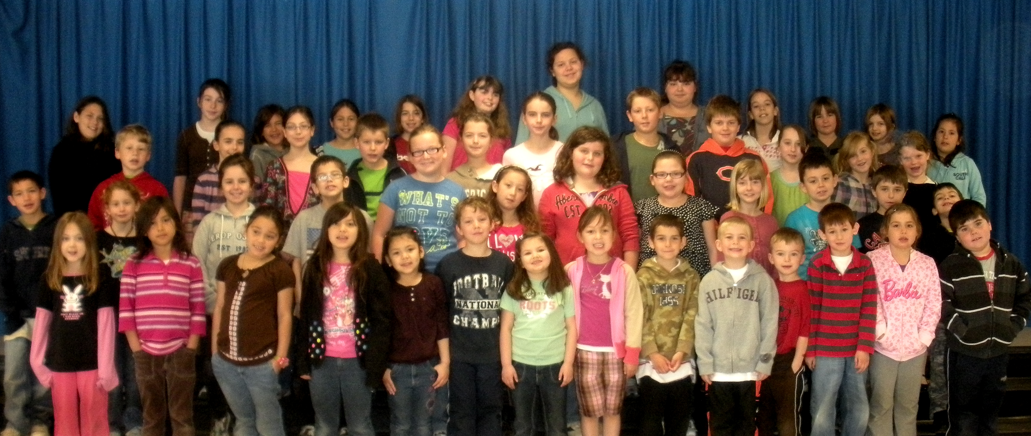

At RES’ November 2010 PSSC Meeting, the Principal will present RES’ 2010-2011 School Improvement Plan based on the results/data obtained from the provincial, District 16 and Rexton Elementary assessments. RES’ Principal will meet with all teaching staff in the fall of 2010 to determine RES’ NB3 and Teacher Leadership goals for the 2010-2011 school year; she will present an update of RES’ 2010-2011 School Improvement Plan objectives to our Parent School Support Committee at our January 2011 PSSC meeting.

Throughout the school year, RES’ Administrators and teaching staff will monitor RES’ SIP progress at October’s Curriculum Implementation Day and again at staff meetings in January, March, and June. RES’ Principal will provide School Improvement Plan updates at its March 2011 PSSC meeting.

In June 2011, RES’ teaching staff and PSSC will receive an update on each of the initiatives in the 2010-2011 School Improvement Plan. We will review the 2010-2011 School Improvement Plan initiatives to see what has been accomplished and brainstorm for additional or different strategies for the 2011-2012 school year.

In late September or early October 2010, we anticipate that the 2010-2011 provincial results will be made available to all schools and we will review these results to determine what modifications need to be made to Rexton Elementary School’s 2008-2011 School Improvement Plan.
Appendix A
RES’ Spring 2010 Grade 2 Provincial Assessments Results

Grade 2 Reading Comprehension:
 | Below Appropriate Achievement | Appropriate Achievement | Strong  Achievement | # of Students
RES 2004 | 38.8% | 50.7% | 10.4% | 67
RES 2005 | 34.4% | 64.1% | 1.6% | 64
RES 2006 | 26.2% | 52.3% | 21.5% | 65
RES 2007 | 8.5% | 63.8% | 27.7% | 47
RES 2008 | 18.8% | 60.4% | 20.8% | 48
RES 2009 | 12.5% | 75.0% | 12.5% | 40
RES 2010 | 22.4% | 51.0% | 26.5% | 49
District 16 2007 | 13.4% | 60.6% | 26.6% | 373
District 16 2008 | 12.9% | 58.6% | 28.4% | 348
District 16 2009 | 13.6% | 68.8% | 17.6% | 295
District 16 2010 |  | 85.9%
Province 2007 | 28.4% | 51.8% | 19.8% | 3930
Province 2008 | 23.8% | 54.7% | 21.4% | 3856
Province 2009 | 17.7% | 59.7% | 22.6% | 3706
Province 2010 |  | 83.6%

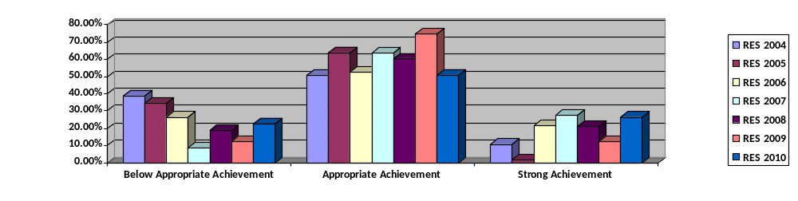
Appendix B
RES’ Spring 2010 Grade 2 Provincial Assessments Results

Grade 2 Writing:
 | Below Appropriate Achievement | Appropriate Achievement | Strong Achievement | No. of Students
RES 2004 | 41.8% | 55.2% | 3.0% | 67
RES 2005 | 53.1% | 46.9% | 0.0% | 64
RES 2006 | 38.5% | 50.8% | 10.8% | 65
RES 2007 | 21.3% | 74.5% | 4.3% | 47
RES 2008 | 35.4% | 58.3% | 6.3% | 48
RES 2009 | 37.5% | 60.0% | 2.5% | 40
RES 2010 | 34.7% | 63.3% | 2.0% | 49
District 16 2007 | 29.8% | 61.1% | 9.1% | 373
District 16 2008 | 29.6% | 65.2% | 5.2% | 348
District 16 2009 | 43.7% | 51.2% | 5.1% | 295
District 16 2010 |  | 68.3%
Province 2007 | 42.8% | 50.8% | 6.3% | 3930
Province 2008 | 40.6% | 54.2% | 5.2% | 3856
Province 2009 | 40.5% | 52.3% | 7.2% | 3706
Province 2010 |  | 70.7%
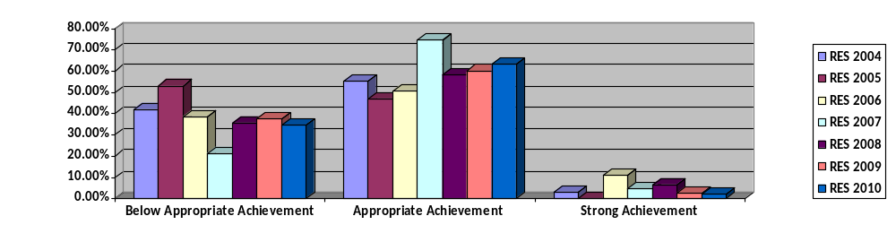

Appendix C
RES’ Spring 2010 Grade 4 Provincial Literacy Assessments Results

Grade 4 Reading Comprehension:
 | Below Appropriate Achievement (%) | Appropriate Achievement (%) | Strong Achievement  (%) | No. of Students
RES 2006 | 26% | 62% | 12% | 69
RES 2007 | 13% | 70% | 17% | 54
RES 2008 | 27% | 64% | 8% | 61
RES 2009 | 5% | 56% | 39% | 52
RES 2010 | 13% | 68% | 19% | 47
District 16 2007 | 21% | 65% | 13.6% | 374
District 16 2008 | 19% | 72.9% | 8.0% | 398
District 2009 | 13% | 56.8% | 29.9% | 375
District 2010 |  | 87.7%
Province 2007 | 30.5% | 57.3% | 12.2% | 4267
Province 2008 | 25.4% | 63.1% | 11.5% | 4295
Province 2009 | 20.9% | 56.0% | 23.1% | 4127
Province 2010 |  | 83.4%
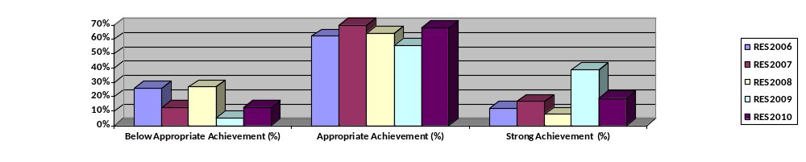
Appendix D
RES’ Spring 2010 Grade 4 Literacy Provincial Assessments Results

Grade 4 Writing:
 | Below Appropriate Achievement | Appropriate Achievement (%) | Strong Achievement (%) | No. of Students
RES 2006 | 65.2% | 31.9% | 2.9% | 69
RES 2007 | 61.1% | 38.9% | 0% | 54
RES 2008 | 62.3% | 34.4% | 3.3% | 61
RES 2009 | 44.2% | 55.8% | .0% | 52
RES 2010 | 44.7% | 51.1% | 4.3% | 47
District 16 2007 | 59.6% | 38.5% | 1.9% | 374
District 16 2008 | 41.5% | 52.5% | 6.0% | 398
District 16 2009 | 36.8% | 56.3% | 6.9% | 375
District 16 2010 |  | 66.2%
Province 2007 | 62.5% | 35.3% | 2.1% | 4267
Province 2008 | 47.0% | 45.9% | 7.1% | 4294
Province 2009 | 43.5% | 51.1% | 5.4% | 4127
Province 2010 |  | 63.2%
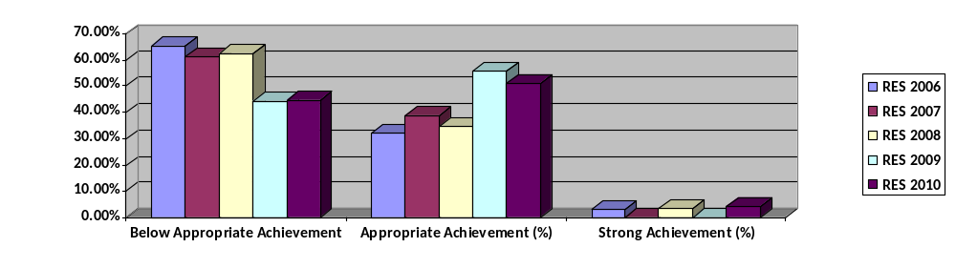
Appendix E
RES’ Grade 5 Provincial Mathematics 2004-2010
 | Math Overall | Performance Level | # of Students
RES 2004 | 77% | SP | 75
RES 2005 | 76% | SP | 61
RES 2006 | 79% | SP | 55
RES 2007 | 72% | AA4 | 74
RES 2008 | 69% | AA4 | 55
RES 2009 | 53% | AA1 | 61
RES 2010 | 65% | AA2 | 52
District 16 2007 | 70% | AA4 | 458
District 16 2008 | 67% | AA3 | 420
District 16 2009 | 59% | AA2 | 439
District 16 2010
Province 2007 | 61% | AA2 | 5926
Province 2008 | 60% | AA2 | 5703
Province 2009 | 56% | AA2 | 5509
Province 2010
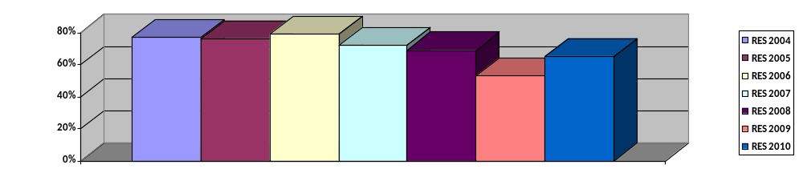
Appendix F

RES’ Grade 5 Provincial Mathematics 2008-2010
 | Below Appropriate Achievement | Appropriate Achievement (%) | Strong Achievement  (%) | Appropriate or Above | No. of Students
RES 2008 | 16.4% | 41.8% | 41.8% | 83.6% | 55
RES 2009 | 45.2% | 40.3% | 14.5% | 54.8% | 62
RES 2010 | 34.6% | 51.9% | 13.5% | 65.4% | 52
District 16 2008 | 21.7% | 39.5% | 38.8% | 78.3% | 420
District 16 2009 | 32.6% | 45.1% | 22.3% | 67.4% | 448
District 16 2010 |  |  |  | 67.5%
Province 2008 | 34.9 | 37.5% | 27.7% | 65.2% | 5703
Province 2009 | 40.6% | 37.1% | 22.3% | 59.4% | 5615
Province 2010 |  |  |  | 59.4%
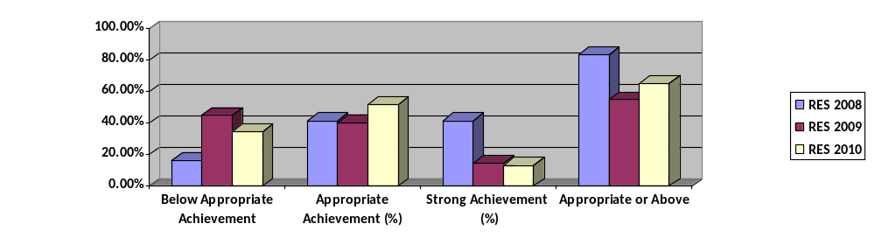
Appendix G
RES’ Grade 5 Provincial Mathematics Assessment Results by Strand
 | Number | Operation | Mental Math | Patterns | Measurement | Geometry | Data | Probability | # of Students
RES. 2007 | 70 | 68 | 68 | 77 | 69 | 69 | 79 | 79 | 74
RES  2008 | 75 | 67 | 56 | 64 | 73 | 76 | 77 | 60 | 55
RES  2009 | 60 | 52 | 39 | 61 | 56 | 46 | 58 | 41 | 61
RES 2010 | 63 |  |  | 84 | 55 |  | 75 |  | 52
District  2007 | 72 | 66 | 71 | 75 | 66 | 68 | 76 | 77 | 445
District 2008 | 72 | 65 | 67 | 67 | 66 | 67 | 73 | 60 | 420
District  2009 | 63 | 59 | 57 | 64 | 55 | 57 | 62 | 55 | 439
District
2010
Province 2007 | 63 | 58 | 58 | 65 | 56 | 61 | 66 | 69 | 5704
Province  2008 | 64 | 59 | 58 | 60 | 57 | 59 | 64 | 54 | 5703
Province  2009 | 61 | 55 | 54 | 62 | 52 | 53 | 58 | 51 | 5509
Province 2010

Appendix H
Rexton Elementary’s Grade 4 District 16 Math Assessment
 | 2008-2009 | 2009-2010
 | # of students | # of students
Strong (90%-100%) | 1 | 2
Competent (70%-89%) | 19 | 1
Acceptable (50%-69%) | 17 | 23
Marginal (30%-49%) | 10 | 15
Weak (0%-29%) | 3 | 2
 | 75% of students scored acceptable or better | 60% of students scored acceptable or better

Appendix I
RES’ 2009-2010 District/School Text Placement Assessment Results
 | Below Appropriate Achievement (%) |  | Appropriate  Achievement (%) |  | Strong  Achievement (%) |  | No. of  Students
 | June 2009 | June 2010 | June 2009 | June 2010 | June 2009 | June 2010 | June 2009 | June 2010
Kindergarten | 27% | 30% | 15% | 70% | 58% | 0% | 48 | 27
Grade 1 | 23% | 18% | 19% | 64% | 57% | 18% | 52 | 39
Grade 2 | 12.5% | 26% | 7.5% | 38% | 80% | 36% | 40 | 53
Grade 3 | 15.2% | 28% | 4.3% | 46% | 80.4% | 26% | 46 | 50
Appendix J
RES’ Fall 2009-Fall 2010 School-Based Text Placement Assessment Results
 | Below Appropriate Achievement |  | Appropriate Achievement (%) |  | Strong Achievement (%) |  | No. of Students
 | Fall 2009 | Fall 2010 | Fall 2009 | Fall 2010 | Fall 2009 | Fall 2010 | Fall 2009 | Fall 2010
Grade 4 | 15.2% | 27% | 63.1% | 41% | 21.7% | 32% | 46 | 41
Grade 5 IF | NA | NA | NA | NA | NA | NA | 52 | 45

Appendix K
RES’ School-based Writing Assessment Results
 | Below Appropriate Achievement (%) |  | Appropriate  Achievement (%) |  | Strong Achievement (%) |  | No. of Students
 | Fall 2009 | Fall 2010 | Fall 2009 | Fall 2010 | Fall 2009 | Fall 2010
 |  | 41% |  | 55% |  | .4% | 27
Grade 1 | 29.4% | 10% | 49% | 59% | 21.5% | 31% | 39
Grade 2 | 41.6% | 31% | 37.5% | 58% | 20.8% | 11% | 53
Grade 3 | 48.7% | 34% | 46.3% | 64% | 5% | 2% | 50
Grade 4 | 45.6% | 39% | 47.4% | 46% | 7% | 15% | 41
Grade 5 IF | NA | NA | NA | NA | NA | NA | 45

