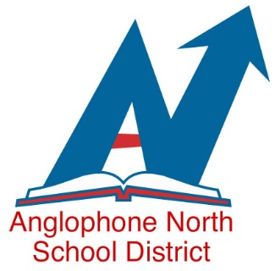

Kindergarten Registration
September 2021

Attention all parents of children born in 2016:
Kindergarten registrations in Anglophone School District North will be occurring in the coming weeks. Registrations this year will be completed by following COVID-19 health protocols. If your child will begin Kindergarten in September 2021, please follow these steps to register:
- Contact your community school by telephone, between September 24 and October 9, to make an appointment for a face-to-face meeting at the school.

- Face-to-face registration appointments will occur from October 13-23 between 8:30 a.m. and 3:00 p.m.

- At the time of your appointment, you will be required to go into the school to complete registration requirements:
- Provide a copy of your child’s birth certificate,
- Provide a copy of your child’s proof of immunization,
- Provide a copy of your child’s Medicare card.

- Please note: Access to the school building will not be permitted without an appointment.

- All visitors to our schools, including parents and children, must wear a community mask upon entering our buildings and follow all health and safety guidelines.

