Snow Day BINGO
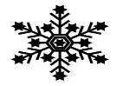
B I N G O
Skip  count by 2’s to 50. | Make a list of 10 words you can spell | How many doubles (2+2=4) can you print? | Sing a song you know from music class. | Build a snowman.
Do 10 jumping jacks. | Do a chore to help out. | Make a list of students in your class. | Shovel some snow. | 30 minutes of non-screen time to work on an activity.
Print all the ways to make 10 (0+10=10, 1+9=10). | Make your bed. | Free Space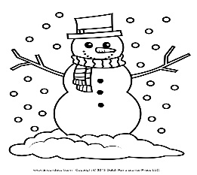 | Count from 0-50. | Make a craft.
Make a list of 10 addition equations you know. | Go sliding! | Read your homework book again. | Make a list of 10 subtraction equations you know. | Read a book with an adult.
Play a game. | Make a list of 10 words you can spell | Count backwards from 30-0. | Play outside in the snow. | Skip count by 10’s to 100.

