
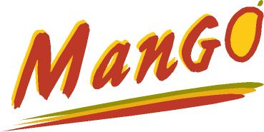
Hello Parents:

Who is “Go For 42” for?
- All school age children.

What is “Go for 42”?
- A 5 week event that lets children complete a marathon (42.2km).

Why “Go For 42”?
- Our partners believe that given the opportunity and encouragement – Kids love to be active! Running (run/walk) is an activity that everyone can do.

When is “Go For 42”?
- May 14 – June 15 in schools, and ending with the Mango Kids Fun Run on June 24th.

Where is the Mango Kids Fun Run?
- Linden Rec. Center (Miramichi West) at 10:30am.

Parents are encouraged to help motivate their kids to participate in this great program. Students will be given a log book to track the distance they have completed.

For more information contact: Renee Murphy 627-7563 renee.murphy@horizonnb.ca or visit school District 16 website www.district16.nbed.nb.ca/ or Rock ‘N Run website www.runmiramichi.ca


Thank you,

Partners/sponsors of the Go for 42 program

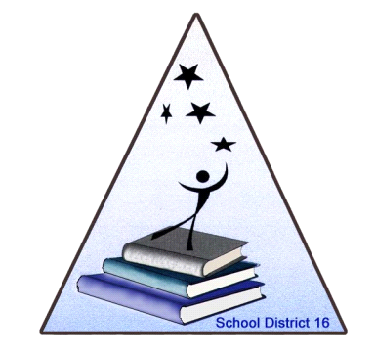



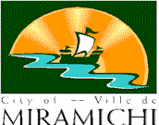


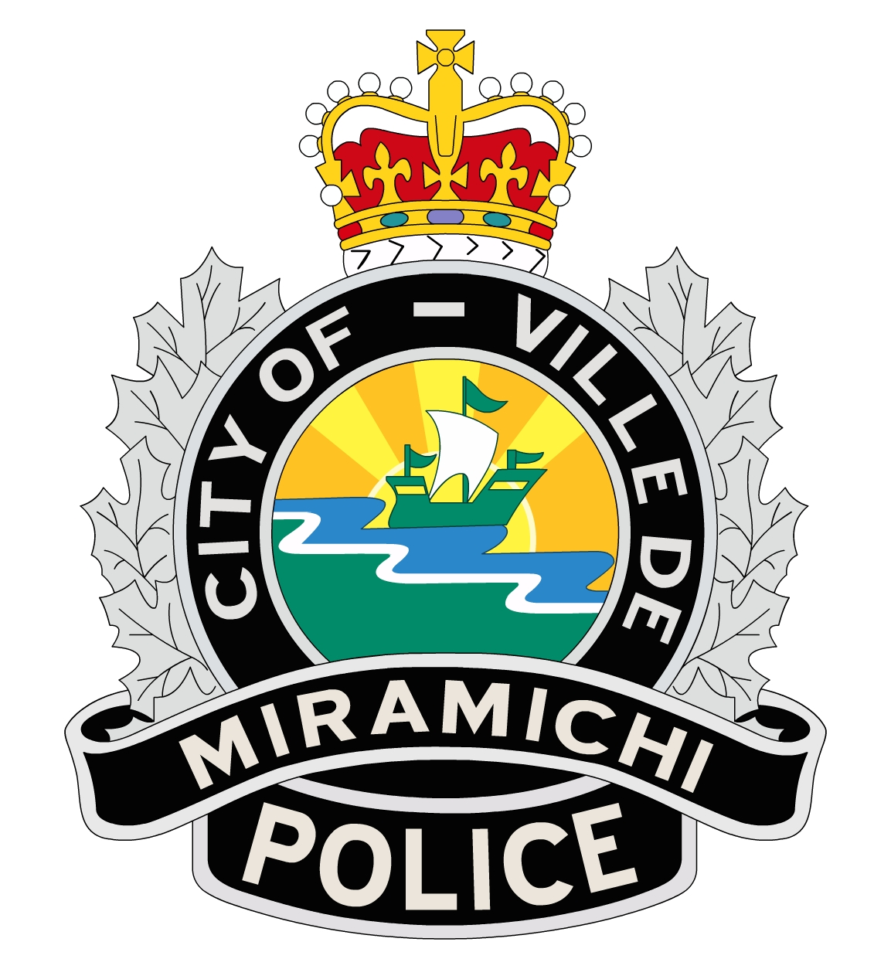
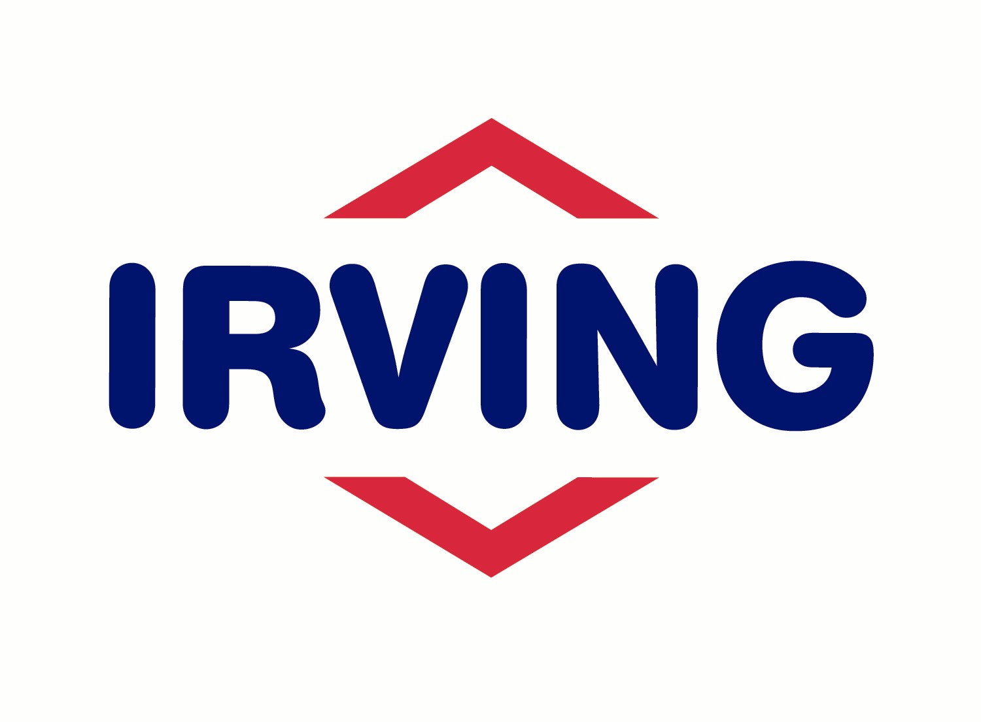

Newcastle Recreation & Leisure Council

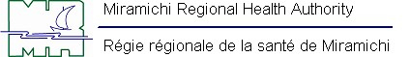

------------------------------------------------------------------------------------------------------------------------------------------------------------------------------

Registration Form for Mango Kids Fun Run on June 24th

Please complete this registration and return to your teacher by June 8th if you would like for your child to participate in the Mango Kids Fun Run on June 24th 2012 at 10:30am.

Name of student:_________________________ Grade:________ School:__________________________
I plan to attend the Mango Kids Fun Run on June 24th: Yes ⁭ No ⁭
(Please check one of these boxes)
Signature:______________________________(Parent/Guardian)

Parent/Guardian would like to volunteer on run day: Yes ⁭ No ⁭
(Please check one of these boxes)
If yes: Parents Name: ______________________________
Telephone number: ________________________ or E-mail address: _______________________________

