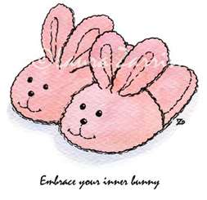
Rexton Elementary students, parents, and staff
RES’ Slipper or Silly Socks Day “fun”draiser
Friday, November 25th, 2001.
All funds raised will help RES & EGMS build a well in Haiti!

