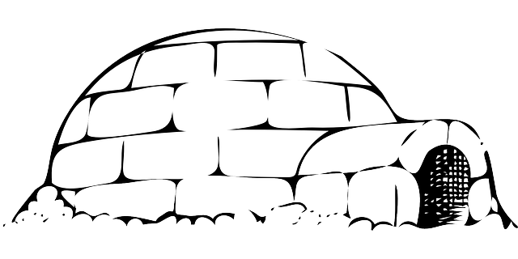
Dear Families,
Welcome to your Snow Day packet! Enclosed are some activities for your child to do when school is cancelled due to weather. There is enough work here for two Snow Days. Please send the completed work in the Homework bag when your child returns to school after the storm.
Per snow day, please complete:
- One page Math word problem/drawing activity
- One day of the fact practice (there are 5 days; but just do one)
- One writing story – there are two options
- And of course…read your book . You can also log into Jelis website for French more books to read, see your child’s Homework bag for log-in info.
- You can also play Zorbit (see duotang for log-in), or some of the Math games listed in your Homework duotang.
- Play outside or play an instrument.
Happy Snow Day!
- Mme Flanagan

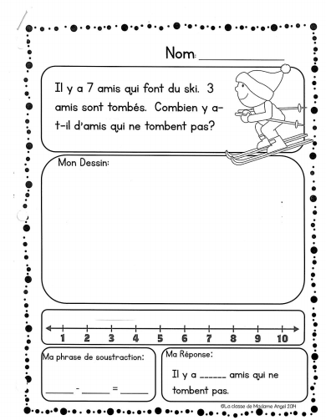
Maths – Option 1
Maths -Option 2
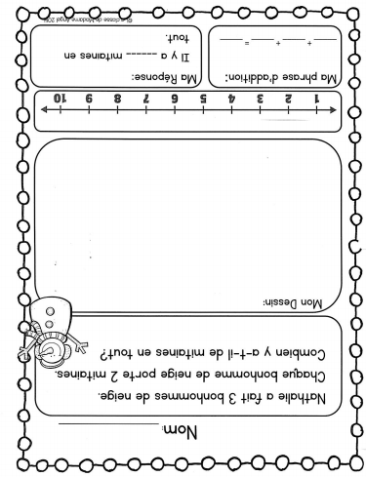

Maths – just do one per snow day
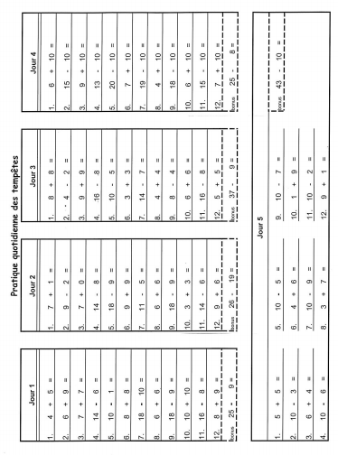
Écriture – Option 1
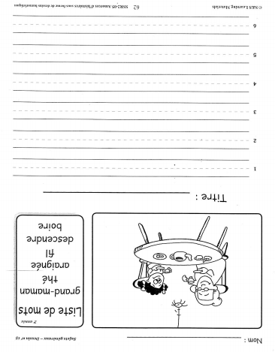

Écriture – Option 2
Va jouer dans la neige ! Reviens dans la maison et écris à propos ce que tu as fait ! Dessine aussi !
Banque de mots :
J’ai joué… pantalon de neige maison
J’ai glissé… les mitaines ma cour (yard)
un traineau ma tuque une pelle (shovel)
un bonhomme de neige mes bottes J’ai pelté la neige
la neige mon manteau J’ai lu un livre
J’ai fait une boule de neige… dehors le vent

