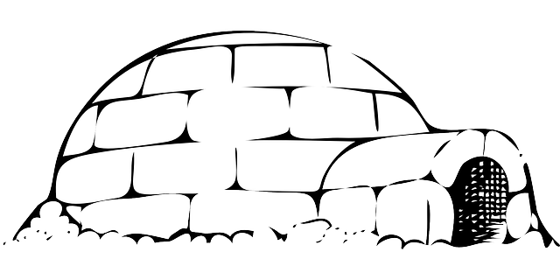
Dear Families,
Welcome to your Snow Day packet! Enclosed are some activities for your child to do when school is cancelled. There is enough work here for two Snow Days. Please send the completed work in the Homework bag when your child returns to school after the storm.
First storm day please complete:
- read for 30 minutes and complete your reading log
- practice your multiplication facts (flash cards, write/copy them, multiplication war etc.)
- play outside for 30 minutes and write about playing outside. Use lots of descriptive language.
- play Netmath, Lalilo, Je lis, Je lis, Littératie, or practice on Typing Club, if possible.

Second storm day please complete:
- read for 30 minutes and complete your reading log
- practice your multiplication facts (flash cards, write/copy them, multiplication war etc.)
- play a board or card game for 30 minutes and write a paragraph about it. Use lots of descriptive language
- play Netmath, Lalilo, Je lis, Je lis, Littératie, or practice on Typing Club, if possible.

Happy Snow Day!
Mme Leonard

