**Home Use**

Timez Attack Setup Instructions

**Downloading Timez Attack:**

1. Go to http://bigbrainz.com/Implementation.php and select **Windows** or **Mac**.



**2.** After it downloads, click on the Timez Attack icon on your desktop.

**3.** Select your student’s Province, District, and School.

Your student’s password is: **Rexton1 .**

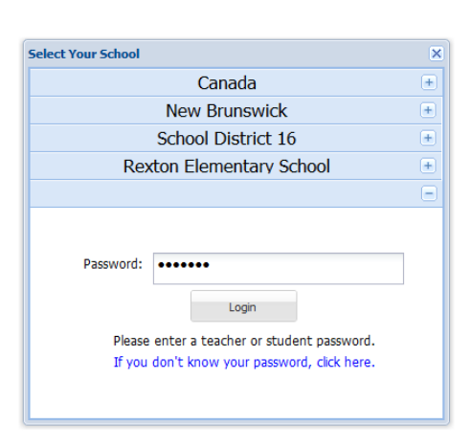

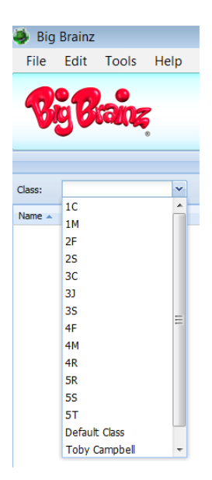

**4.** Select the student’s class. Then

click on the student’s ID, which

begins with the first 2 letters of

their first and last name.

Tech questions? Call 877-356-7040

or email

jessica@bigbrainz.com.

Password questions? Contact your teacher.