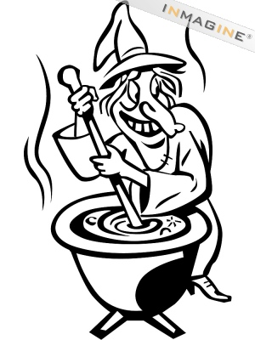
"Witches Stew"
Bubble, blubber, squirm and gloop,
Boiling broth of bat's tail soup.
Wobble, slobber, liquid goo,
Add the sole of one old shoe.
Spooky shadows dance around,
Of frogs and rats and snarling hounds.
Steam swirls rising to the roof,
Add one small ear and one old tooth.
Gnarly, scratchy, tickle and itch,
Stir round and round to make it rich.
Mushy, sticky, sizzle and stew,
They're making mischief just for you!

BY: Gareth Lancaster

